SUPPLEMENTAL INFORMATION

Proximity of Informal Worker Housing to Industrial Zones in Hanoi, Vietnam: Associated Environmental Health Risks in Air and Drinking Water
Nicole M. DeLuca,^{1*} Riley E. Mulhern,² Mai Thi Nguyen,³ Tho Tran,⁴ Andrea McWilliams,¹ Frank Weber,¹ Keith Levine,¹Laura Allen Gates¹, Jennifer Hoponick Redmon^{1*}
1 – RTI International, Research Triangle Park, NC, USA
2 – University of Colorado Boulder, CO, USA
3– University of California at San Diego, San Diego, CA, USA
4 – Hampton Roads Planning District Commission, Chesapeake, VA, USA
*Corresponding authors: Nicole DeLuca and (ndeluca@rti.org) and Jennifer Hoponick Redmon (jredmon@rti.org)

Table S1. Limit of detection (LOD) and estimated limit of quantification (ELOQ) for analytes measured in water samples.
Analyte | LOD | ELOQ
As | 0.001880 | 0.0250
Ba | 0.002060 | 0.0250
Be | 0.001660 | 0.0250
Cd | 0.000607 | 0.0250
Co | 0.000264 | 0.0250
Cs | 0.000235 | 0.0250
Cu | 0.003190 | 0.0250
Mn | 0.002920 | 0.0250
Mo | 0.005560 | 0.0250
Ni | 0.001670 | 0.0250
Pb | 0.000301 | 0.0250
Pt | 0.000442 | 0.0250
Sb | 0.000875 | 0.0250
Se | 0.015000 | 0.2500
Sn | 0.011900 | 0.0500
Sr | 0.000993 | 0.0250
Tl | 0.030300 | 0.0250
U | 0.000163 | 0.0250
V | 0.059600 | 0.0250
W | 0.036300 | 0.0250
Zn | 0.013200 | 0.1000

Table S2. Drinking water guidelines, standards, or recommendations for contaminants measured in this study.
Contaminant | WHO¹ | Vietnam² | U.S. EPA MCL³ | U.S. EPA SMCL⁴ | AAP⁵
As | 10ª | 10 | 10
Ba | 1300 | 1300 | 2000
Be | 12^{b} |  | 4
Cd | 3 | 3 | 5
Co
Cs
Cu | 2000 | 1000 | 1300e | 1000
Mn | 80^{c} | 100 |  | 50
Mo | ^{b}
Ni | 70 | 70
Pb | 10ª | 10 | 10e |  | 1
Pt
Sb | 20 | 20 | 6
Se | 40^{c} | 40 | 50
Sn | ^{d}
Sr
Tl |  |  | 2
U | 30^{c} |  | 30
V
W
Zn | ^{d} | 2000 |  | 5000
¹World Health Organization’s (WHO) Guidelines for Drinking-Water Quality; Fourth Edition Incorporating the First and Second Addenda (2022).
²Vietnam Ministry of Health’s National Technical Regulation on Domestic Water Quality (2024).
³U.S. Environmental Protection Agency’s (EPA) National Primary Drinking Water Regulations; Maximum Contaminant Level (MCL) (2024).
⁴U.S. Environmental Protection Agency’s (EPA) National Secondary Drinking Water Regulations; Secondary Maximum Contaminant Level (SMCL) (2020).
⁵American Academy of Pediatrics’ Prevention of Childhood Lead Toxicity (2016).
ªProvisional guideline value; calculated guideline value below achievable quantification level, below achievable level through practical intervention methods.
^{b}No guideline established; health-based value.
^{c}Provisional guideline value; uncertainties in or lack of health data.
^{d}No guideline established; no health concern at levels found in drinking water.
^{e}No MCL established; enforceable treatment technique to control corrosiveness of water if 10% of samples exceed this action level.

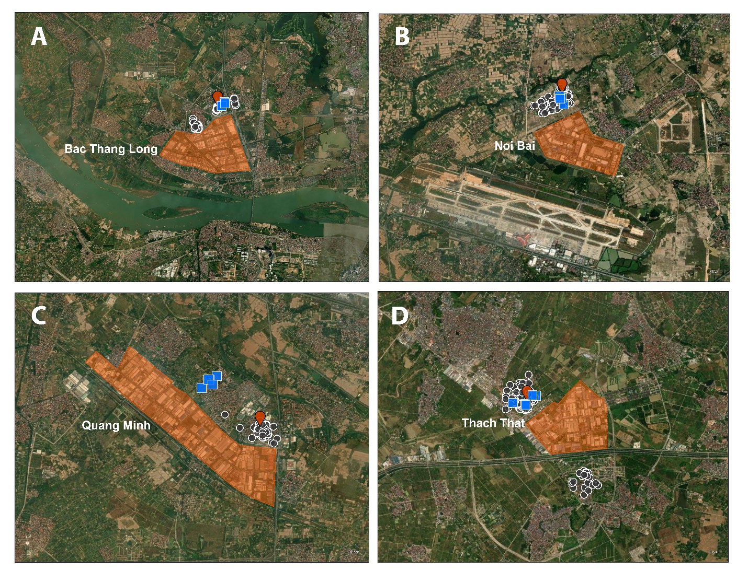
Figure S1. Zoomed in maps of industrial zones (orange) A) Bac Thang Long, B) Noi Bai, C) Quang Minh, and D) Thach That surrounding Hanoi, Vietnam with drinking water sampling (blue squares), ambient air sampling (red pin), and previously surveyed household (grey circles) locations.

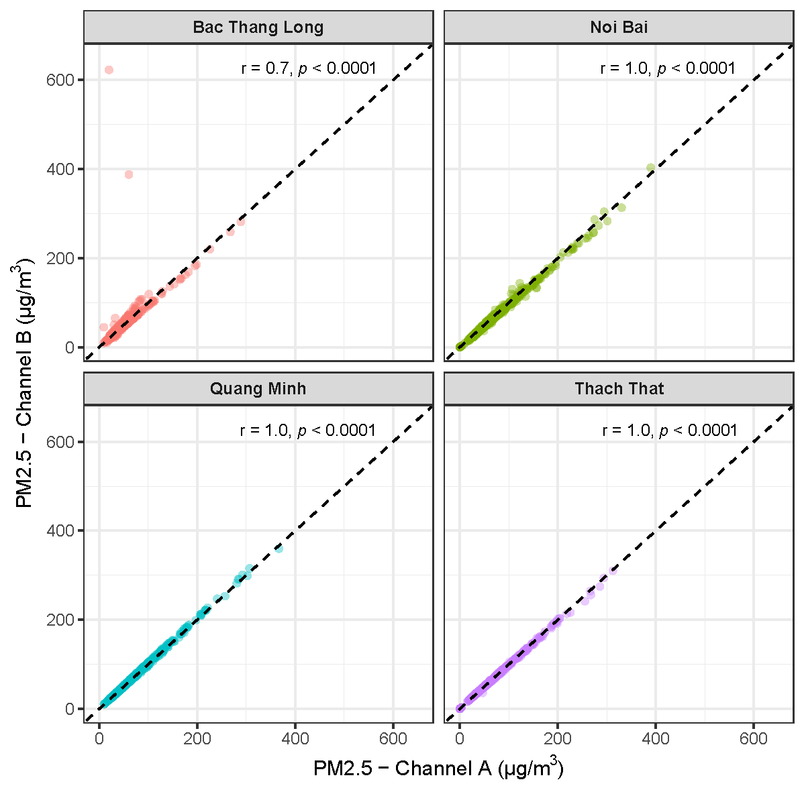
Figure S2. Comparison of 24-hour PM2.5 data between the two channels in the PurpleAir devices for all four industrial zones, including Pearson correlation coefficient (r) and p-value.

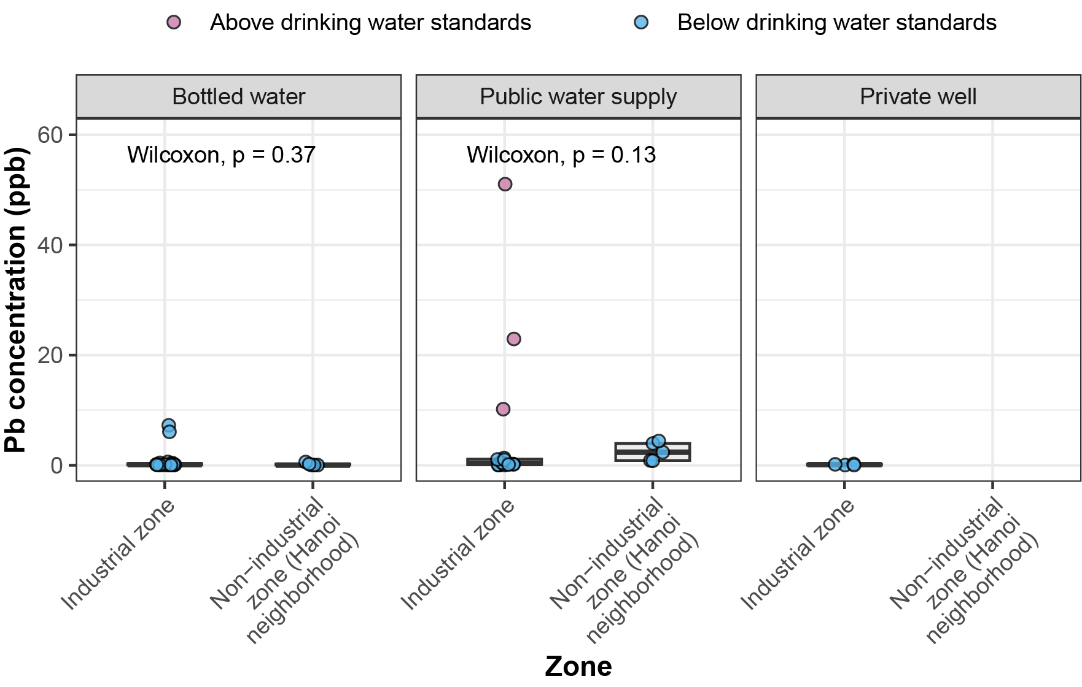
Figure S3. Comparison of lead concentrations in household water sources in industrial zones versus the non-industrial neighborhood of Hanoi. Colors indicate whether the result was above or below WHO, Vietnamese, and/or EPA drinking water standards.
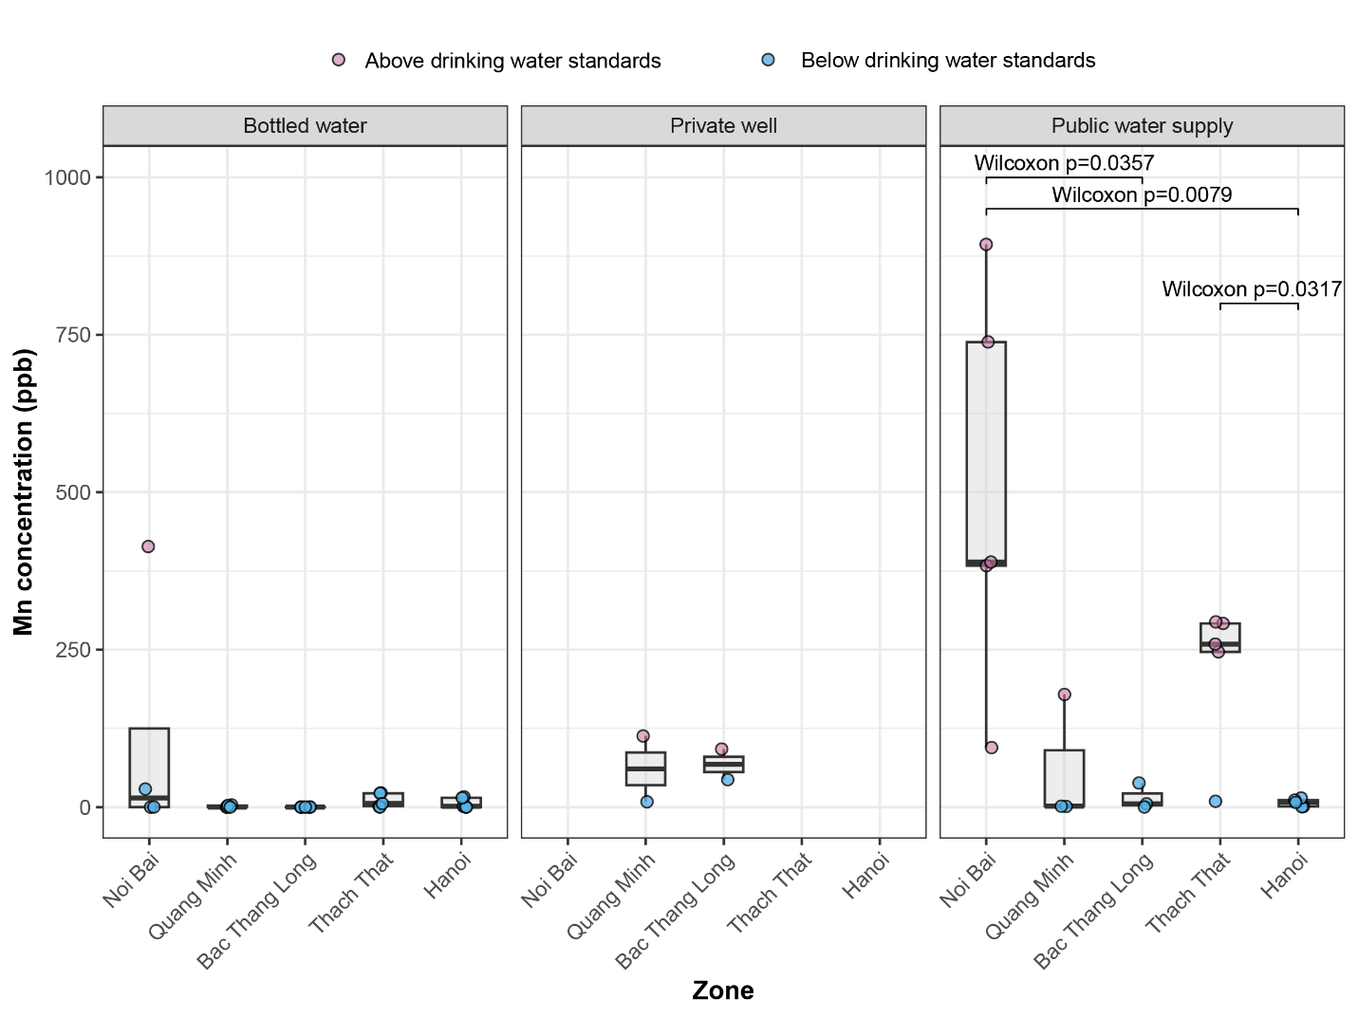
Figure S4. Comparison of manganese concentrations in household water sources in industrial zones and Hanoi. Colors indicate whether the result was above or below WHO, Vietnamese, and/or EPA drinking water standards.

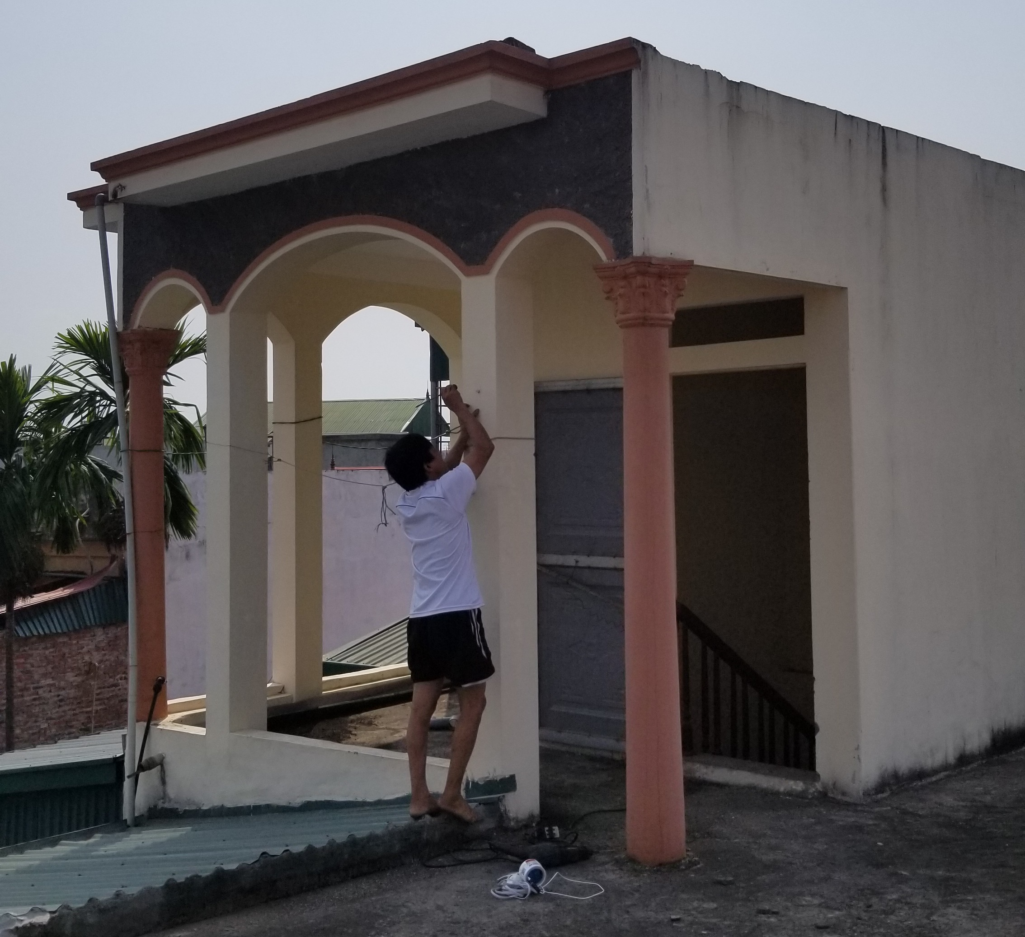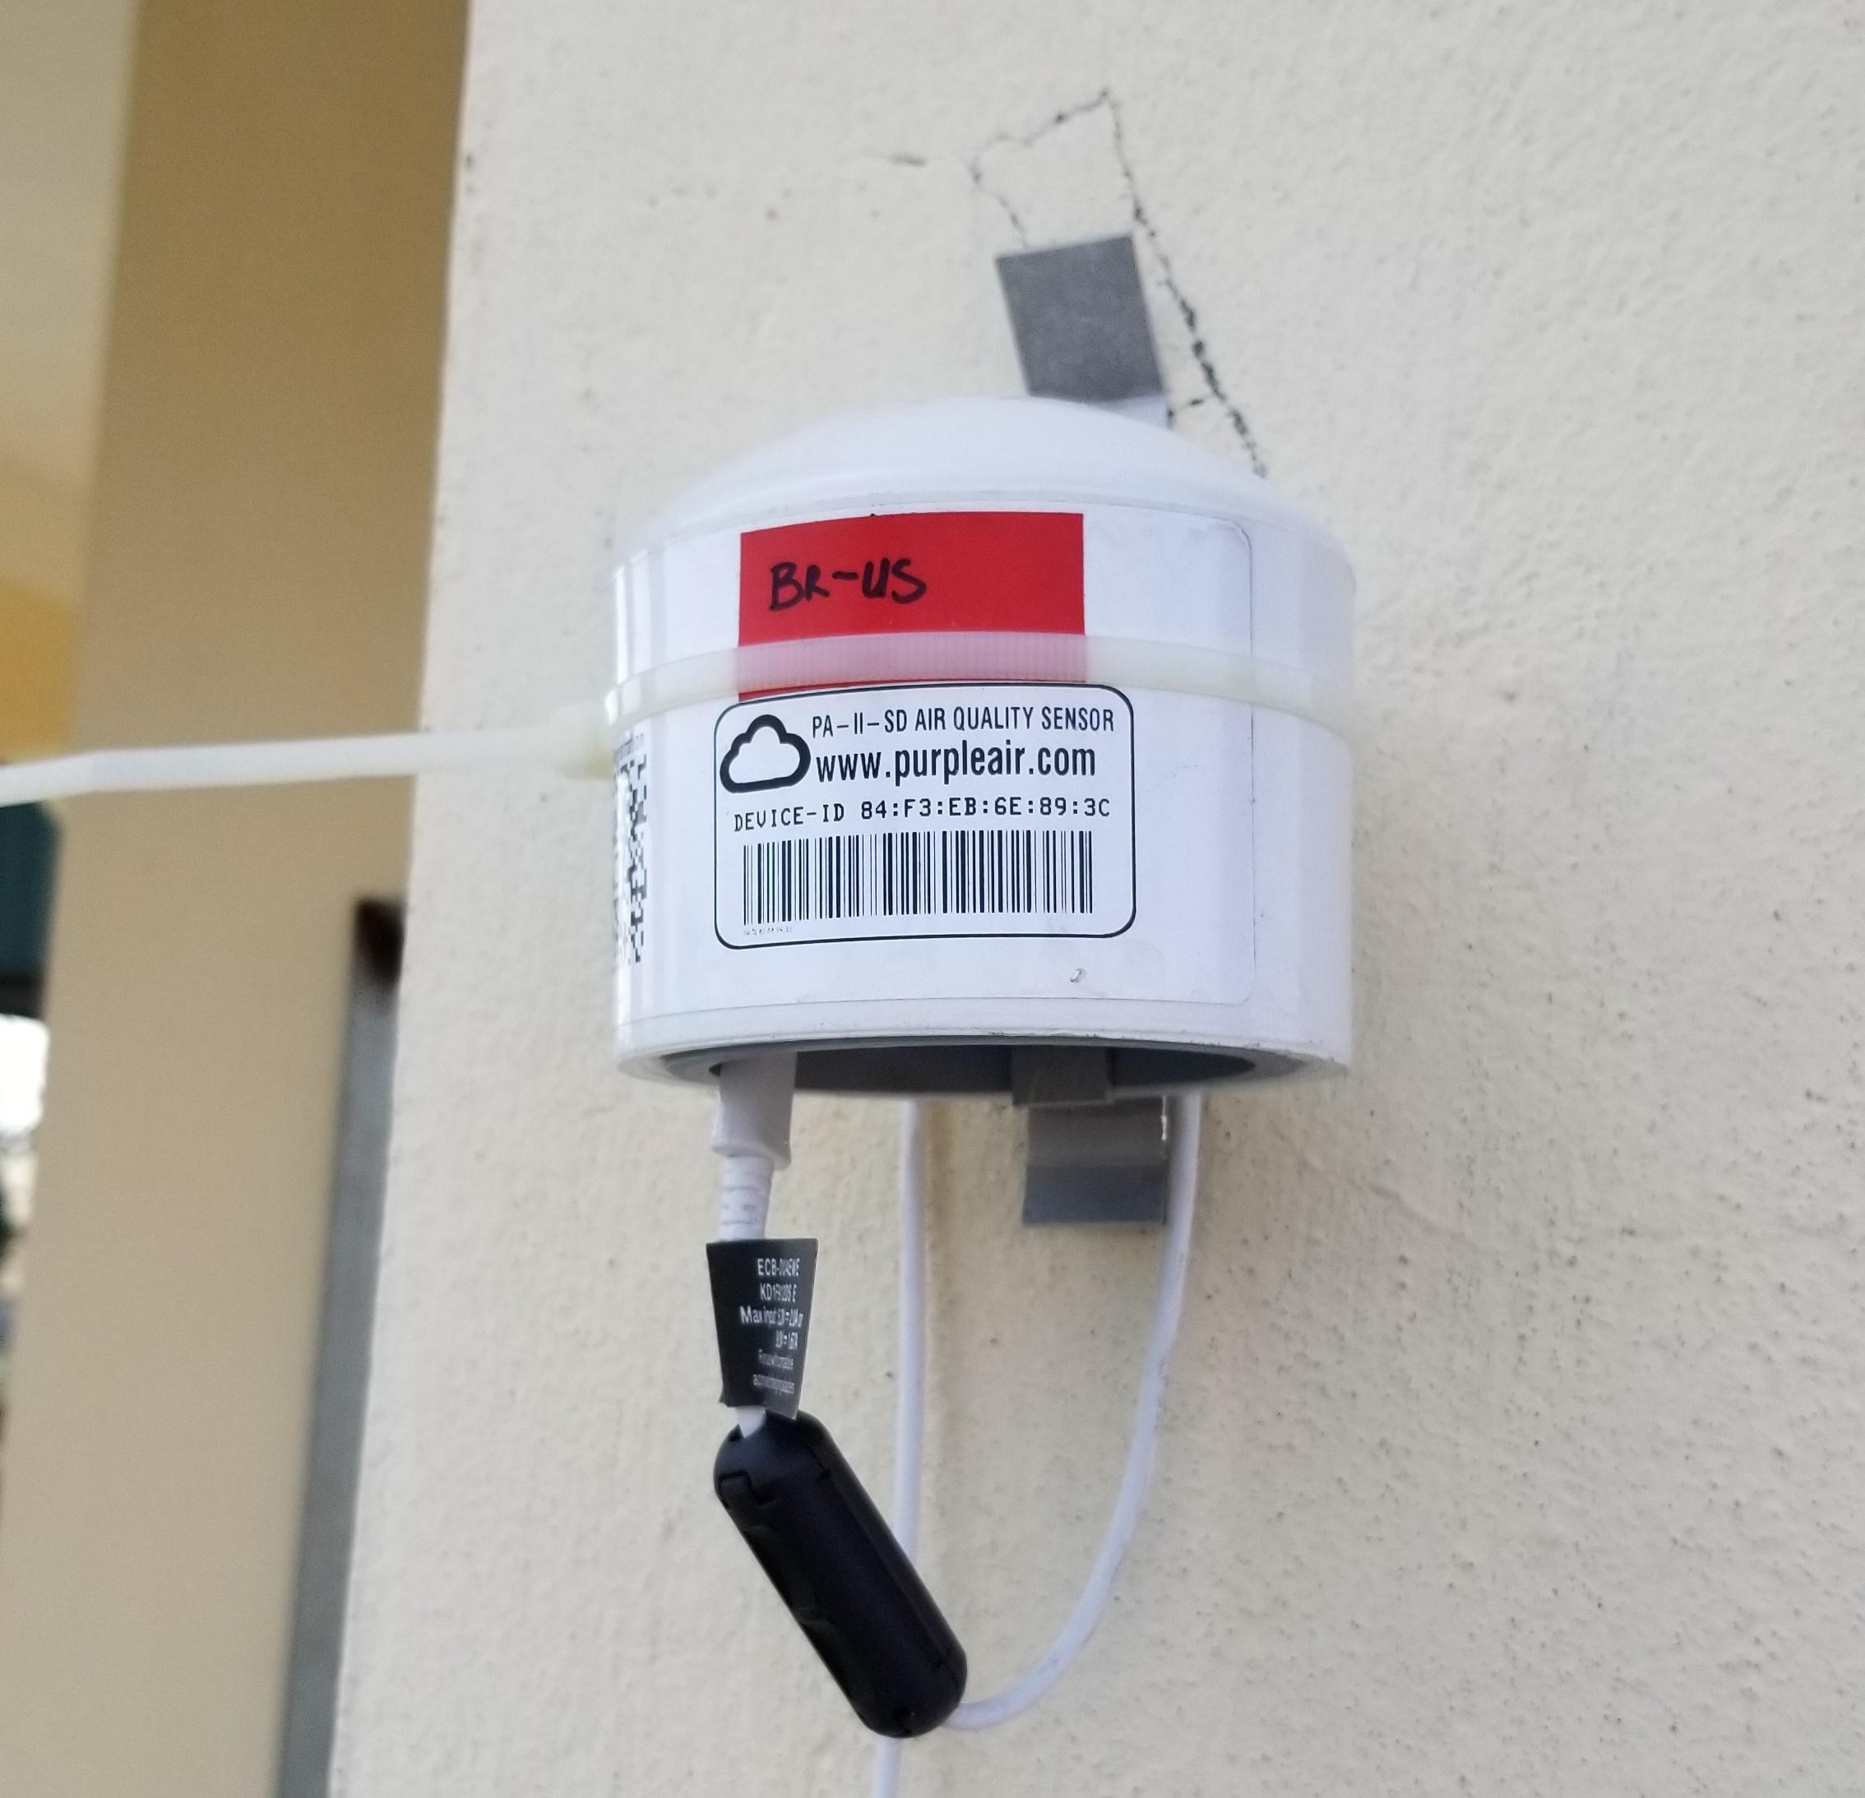
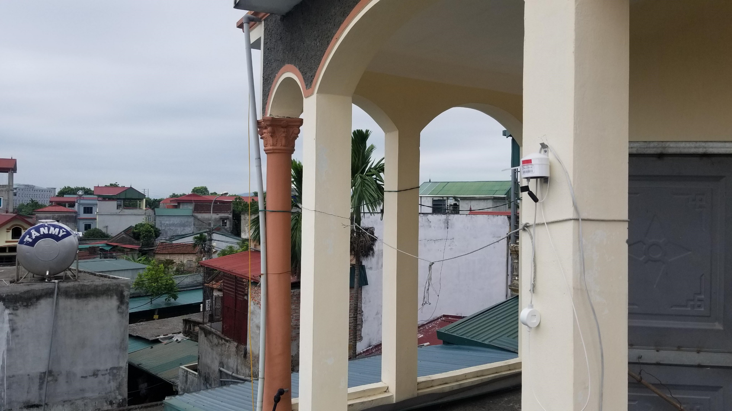
Figure S5A. Photos of the air monitor placed within the Thach That Industrial Zone in Vietnam.
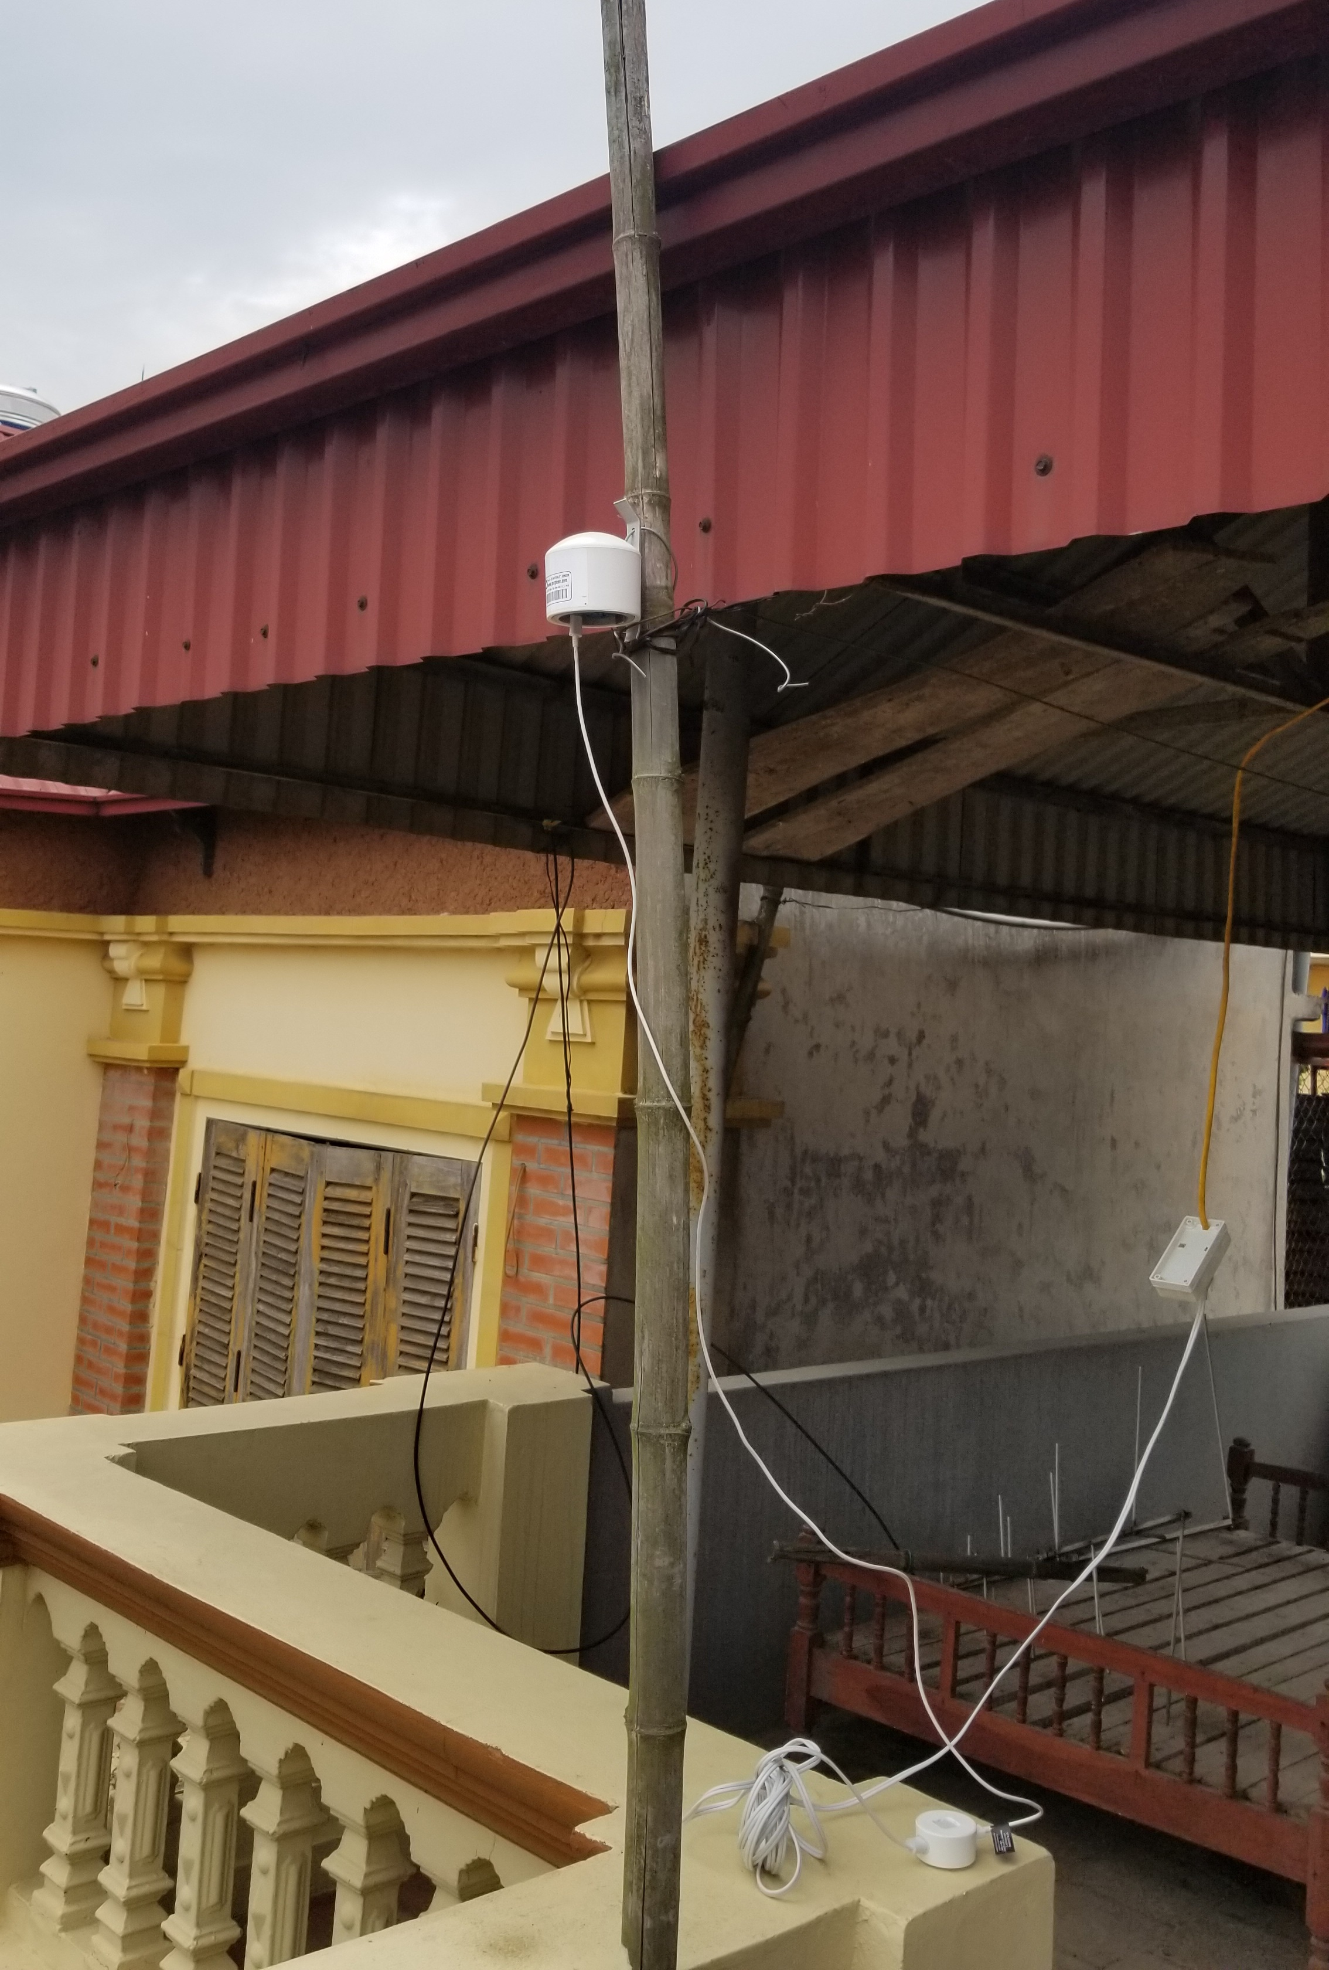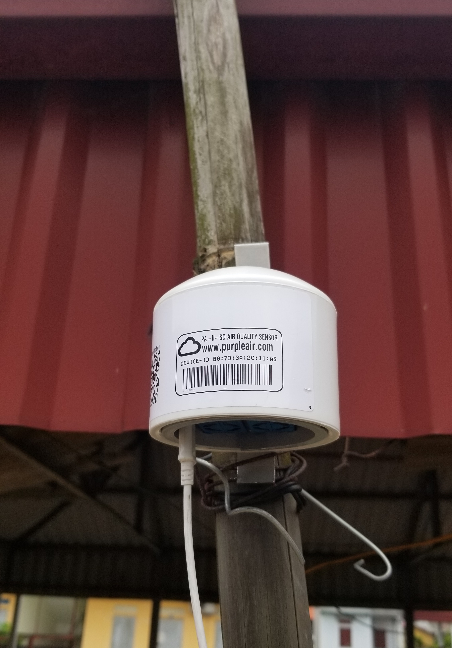
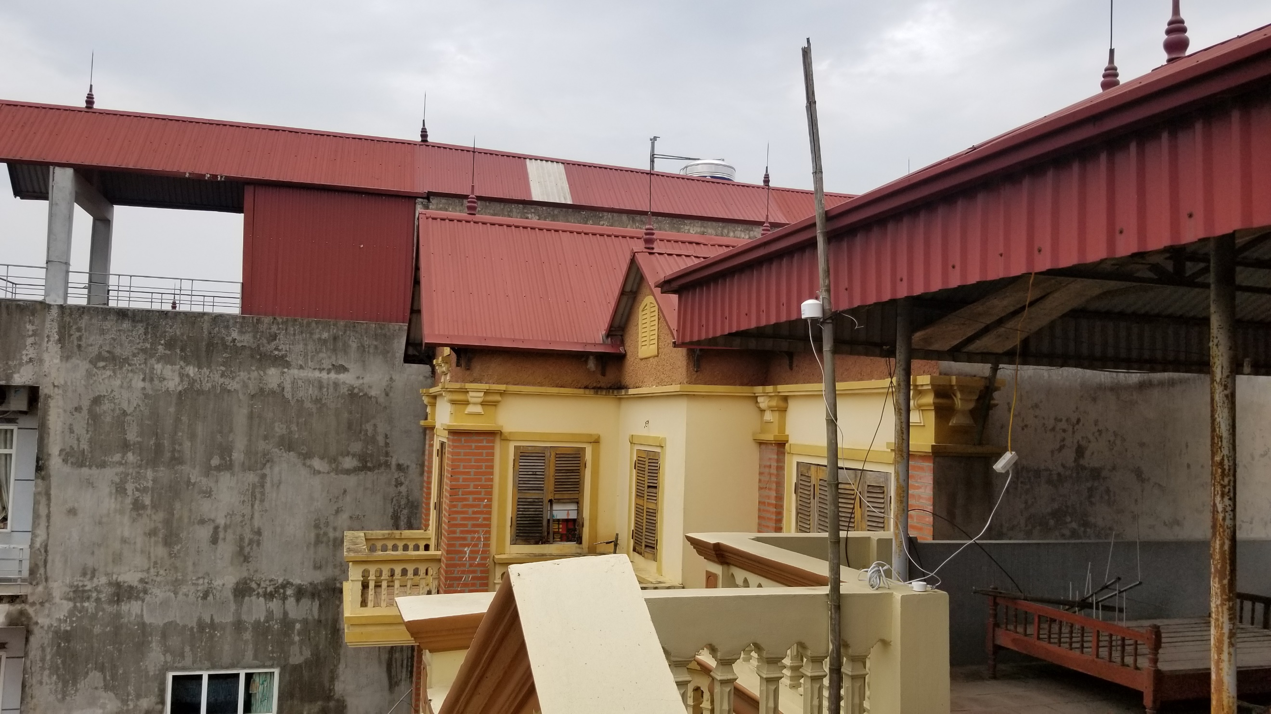
Figure S5B. Photos of the air monitor placed within the Quang Minh Industrial Zone in Vietnam.
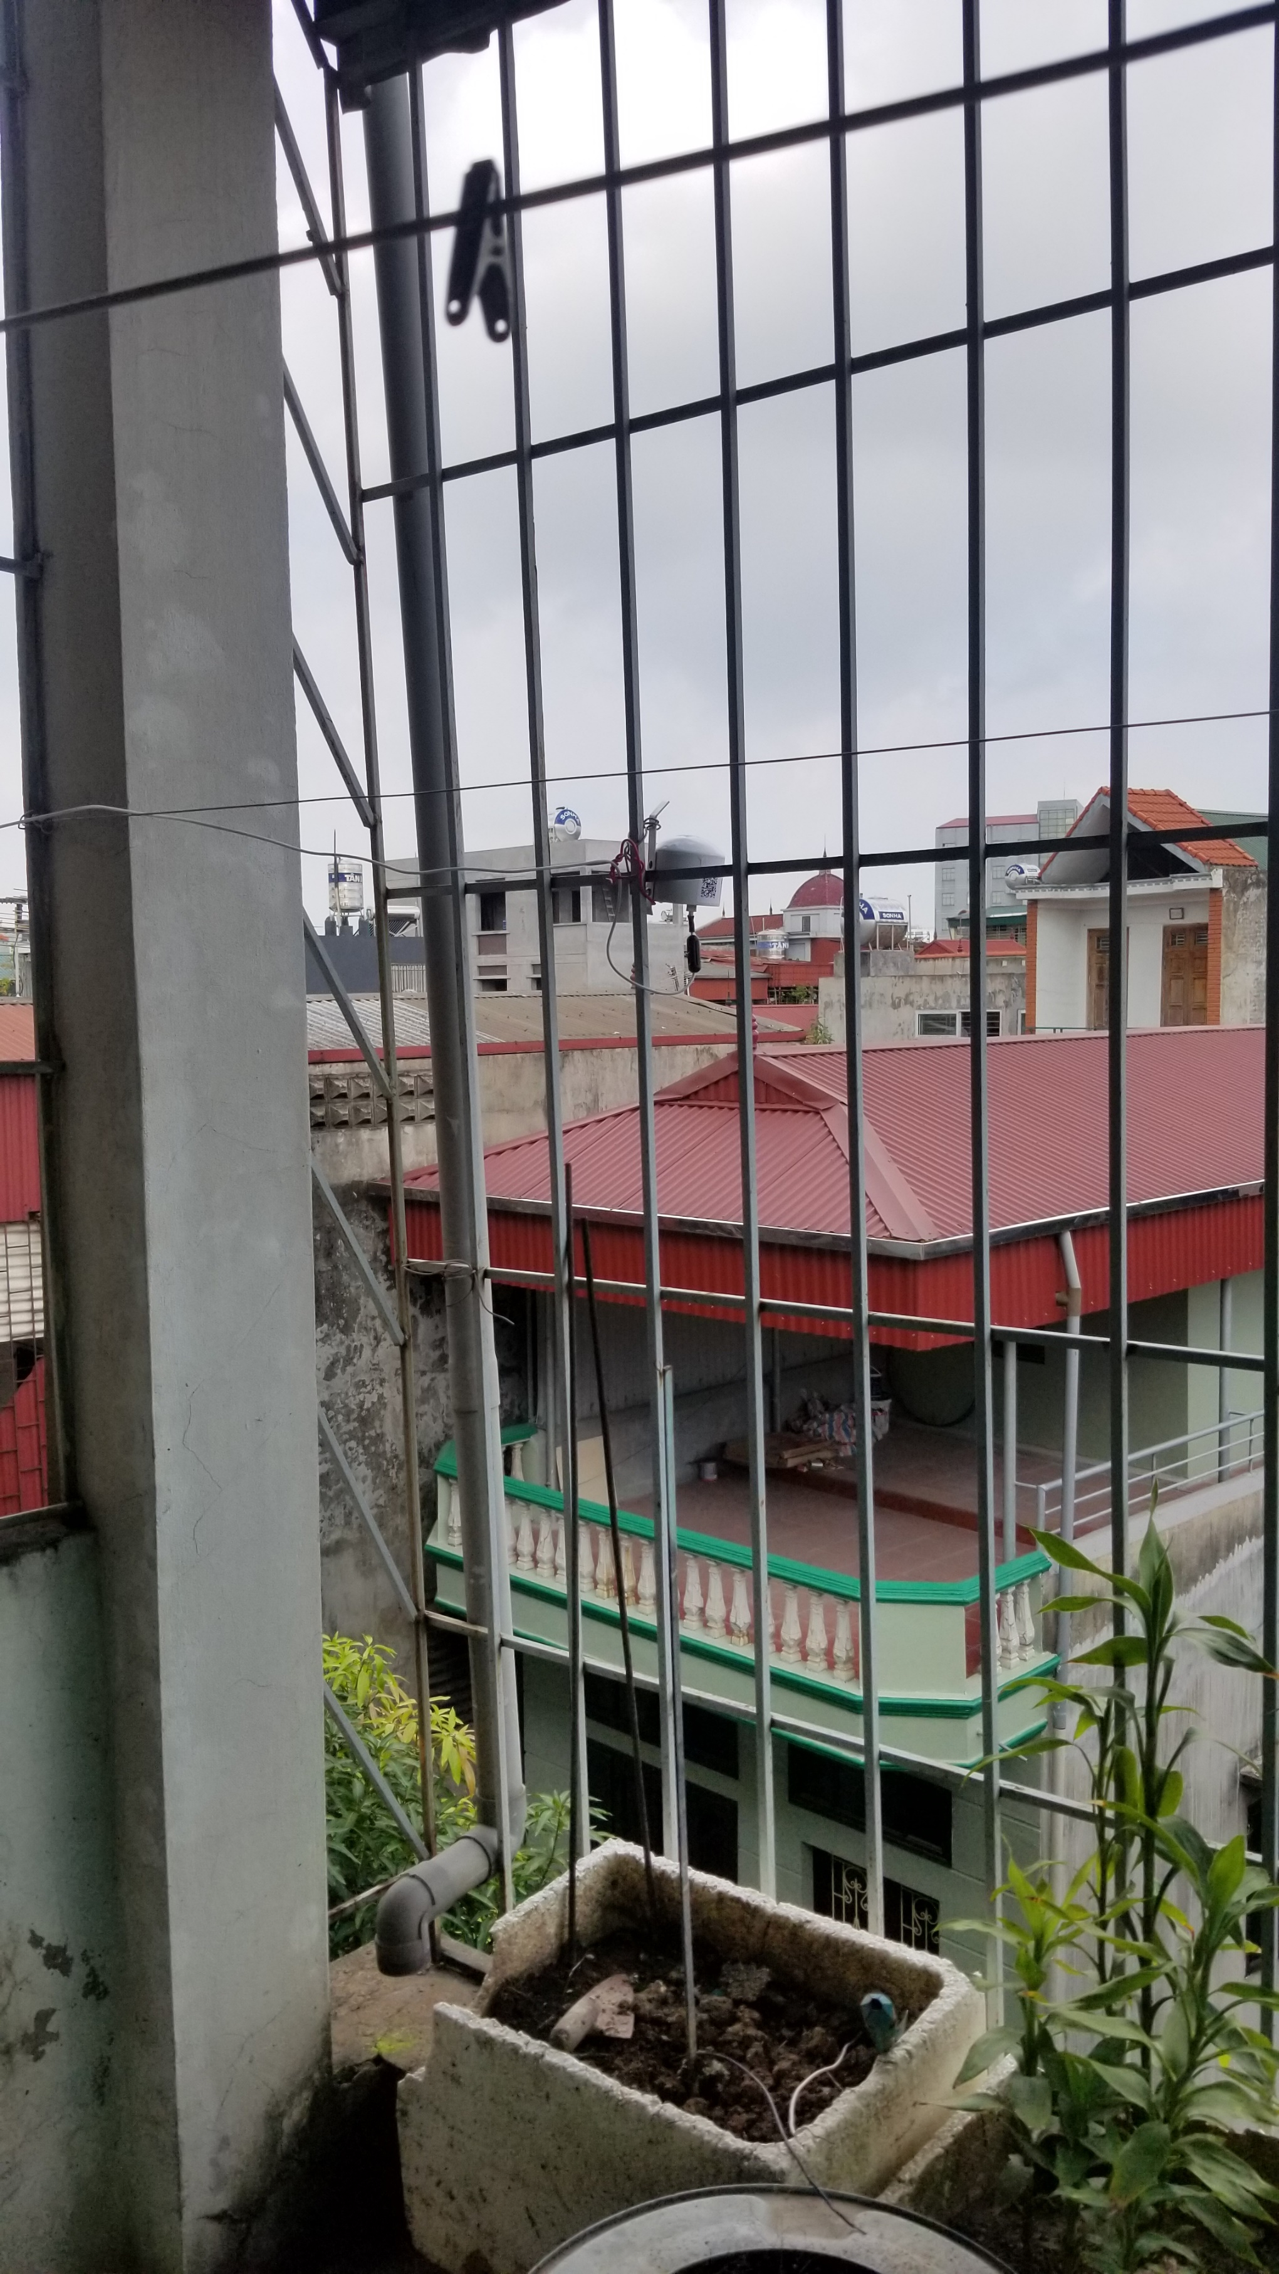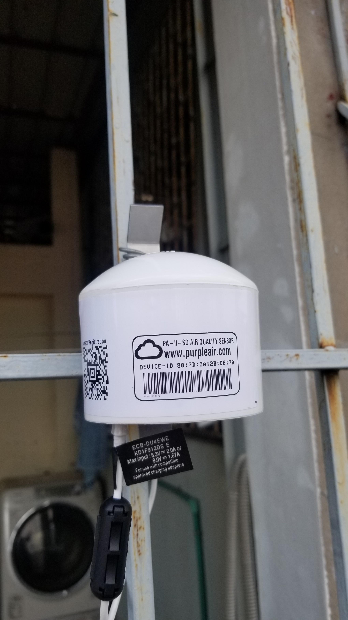
Figure S5C. Photos of the air monitor placed within the Noi Bai Industrial Zone in Vietnam.

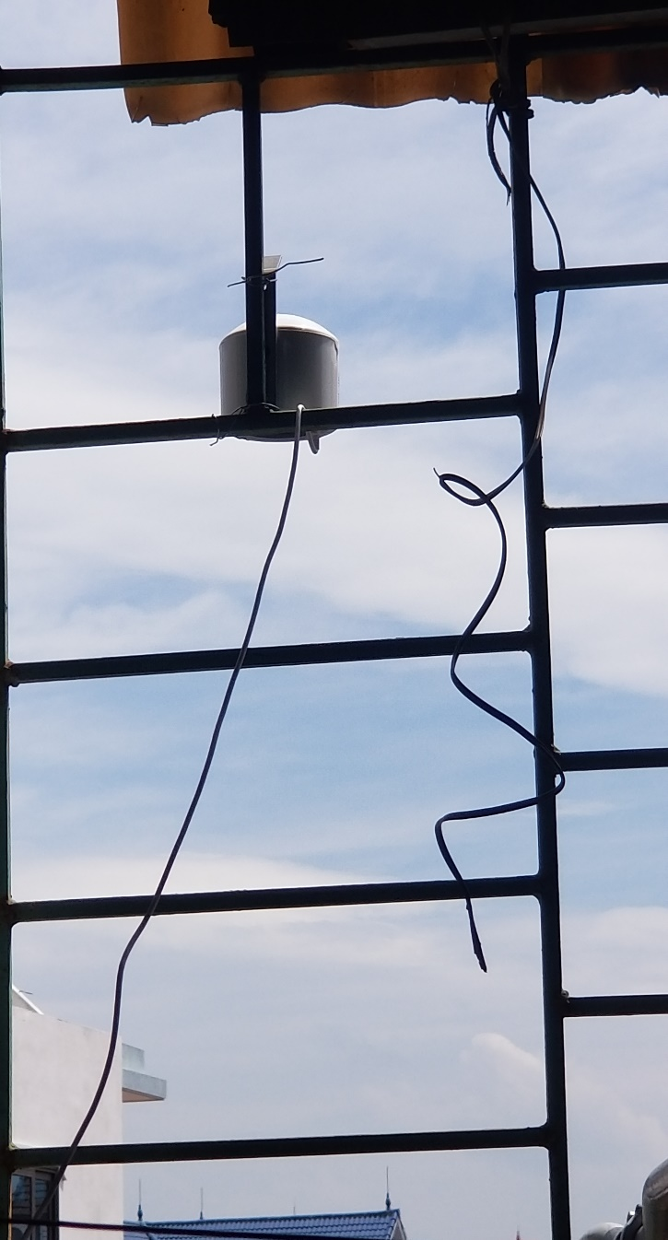
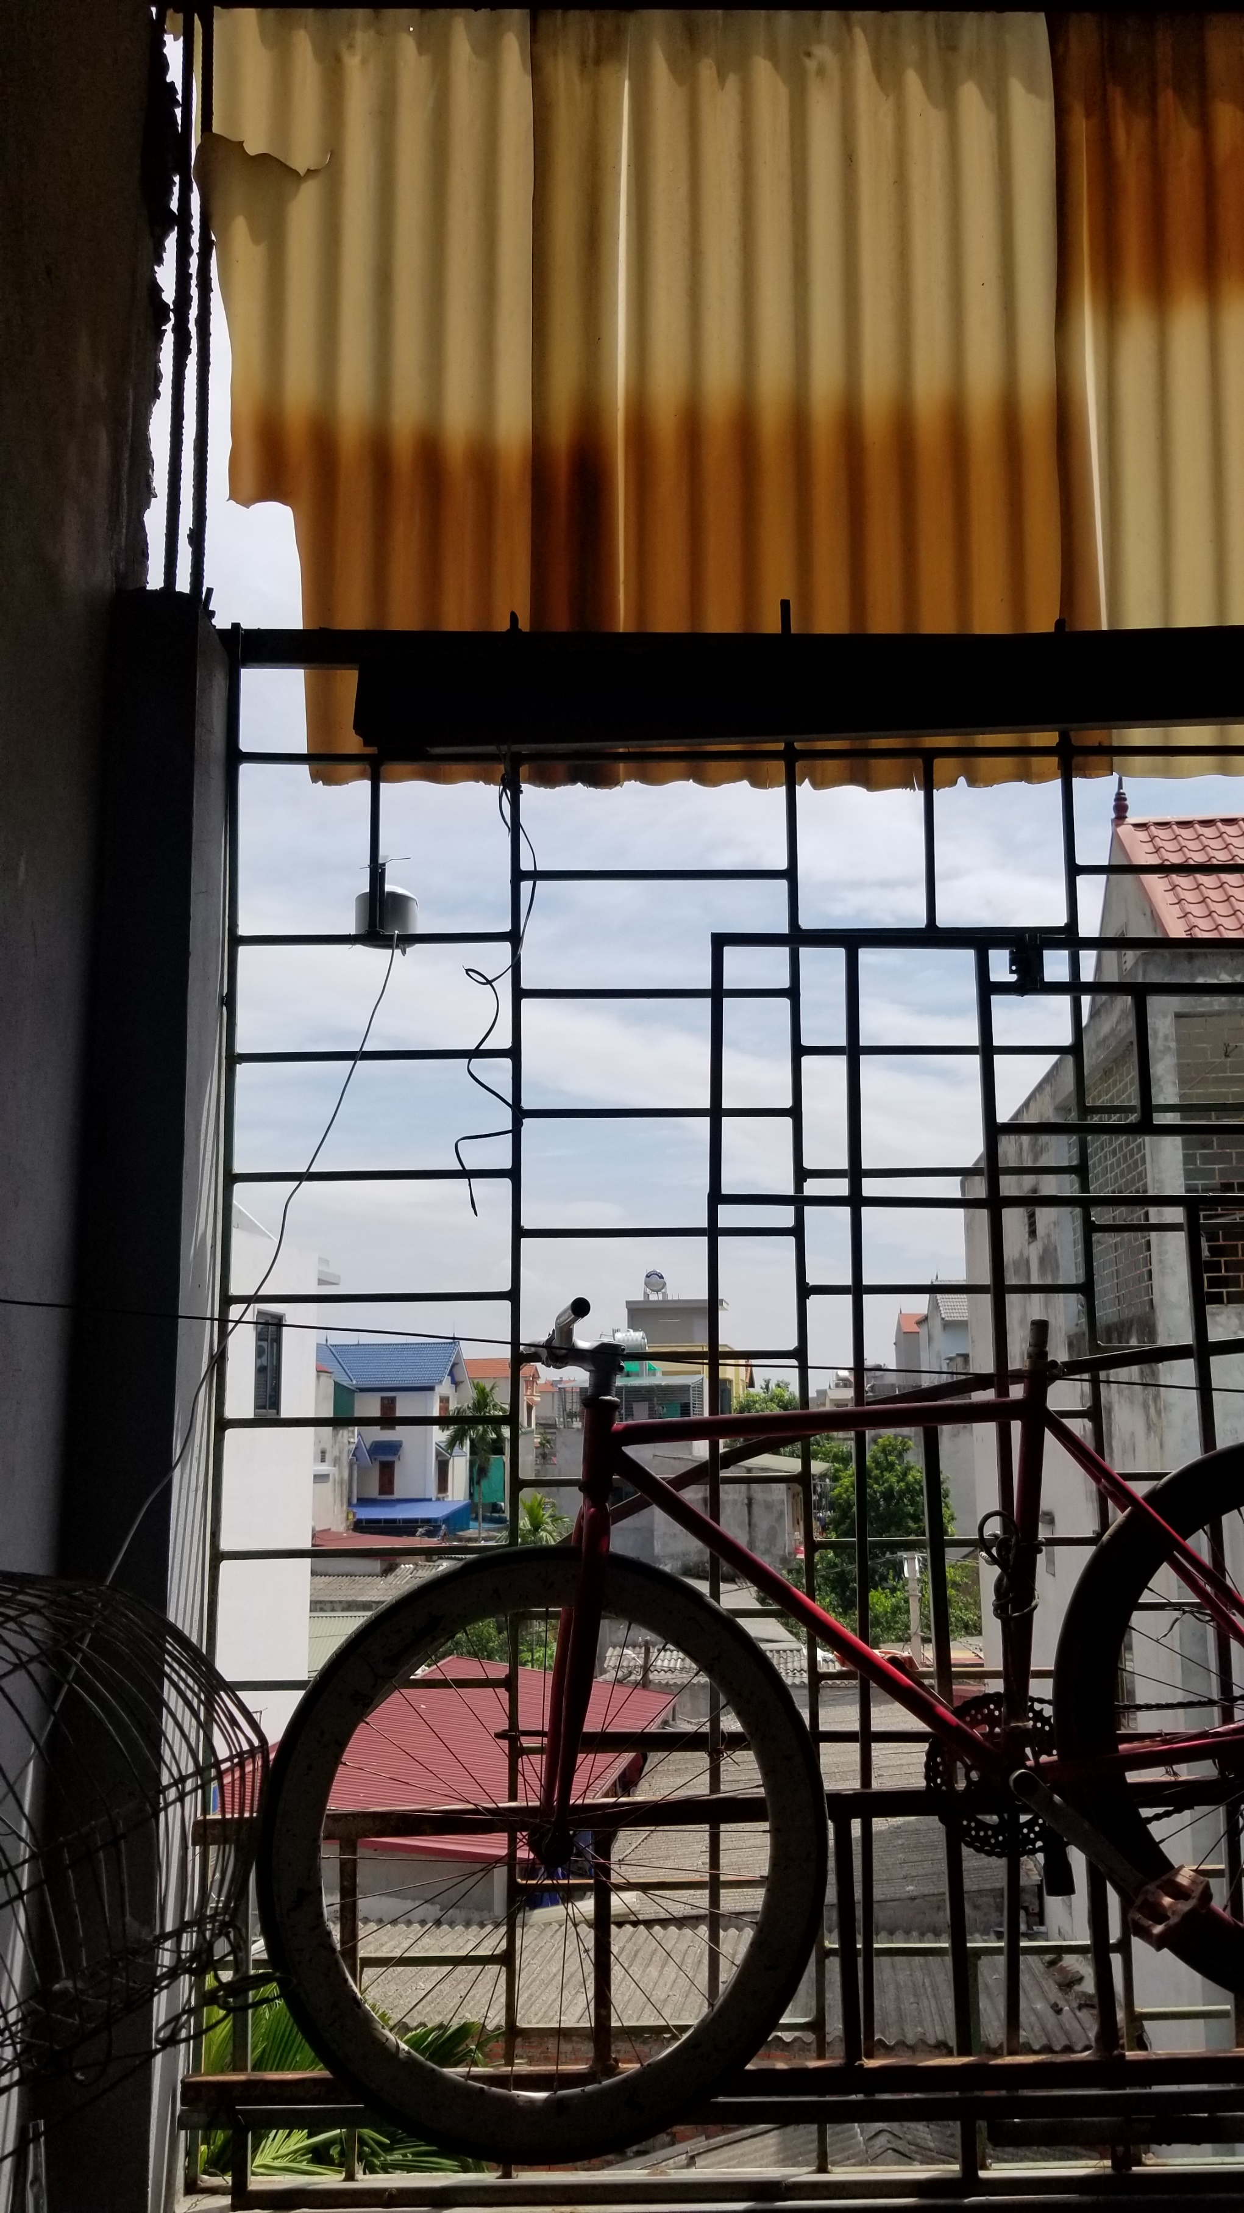
Figure S5D. Photos of the air monitor placed within the Bac Thang Long Industrial Zone in Vietnam.

